**Behavior Model for US FNMA and GNMA CMBS (QRM MFPM v2)**

*Model ID# 2603*

**Model Owner:** Randhir Ahluwalia, ALM Interest Rate Risk

**Model Developer:** QRM

**Model User(s):** ALM Interest Rate Risk

**Documentation Date:** 12 October, 2016

**Validation Report:**

**Purpose and Use**

1. Purpose of Model: The Multi-Family Prepayment Model (MFPM v2) is QRM’s proprietary model for prepayments on mortgages that comprise Fannie Mae (FNMA) and Ginnie Mae (GNMA) multifamily mortgage-backed securities (MBS) and uses a combination of loan- and pool-level data from GNMA and FNMA. The MFPM does not cover Freddie Mac (FHLMC) multifamily MBS, also known as “K- Deals”. The purpose of the MFPM v2 is to describe how prepayment rates depend on contractual features, borrower characteristics, and economic factors. The MFPM consists of three models: a model for prepayments on GNMA mortgages, another for voluntary prepayments on FNMA mortgages, and another for involuntary prepayments on FNMA mortgages. The model also uses two sub-models, one for HPI and the other for Unemployment Rate which are inputs to the prepayment model as macro-economic variables. The model will provide prepayment for the FNMA and GNMA CMBS securities held on the firm’s balance sheet. MFPM v2 is integrated within the Quantitative Risk Management (QRM) platform which is used for Economic Value of Equity (EVE), Net Interest Income (NII) projection, CCAR OCI and Basel Interest Rate Economic Capital.
2. Scope: MFPM v2 will be utilized for FNMA and GNMA CMBS securities for business as usual practices and regulatory stress testing. ALM IRR will use MFPM v2, as well as other BNYM groups (e.g., ALM Liquidity, Market Risk). This model will help BNYM better model cash flows for the FNMA and GNMA CMBS securities, replacing the QRM’s older version of CHRM model.
3. Limitations:

1. MFPM v2 model for GNMA multifamily mortgages was built including loans in all pools except construction pools.

2. MFPM V2 model for GNMA multifamily mortgages does not split prepayments into voluntary and involuntary prepayments due to the underlying historical data not being available in that manner. However, involuntary prepayment has historically been a very small portion of total prepayment (using FNMA pools as proxy) and very sporadic and thus lack of this feature was deemed acceptable.

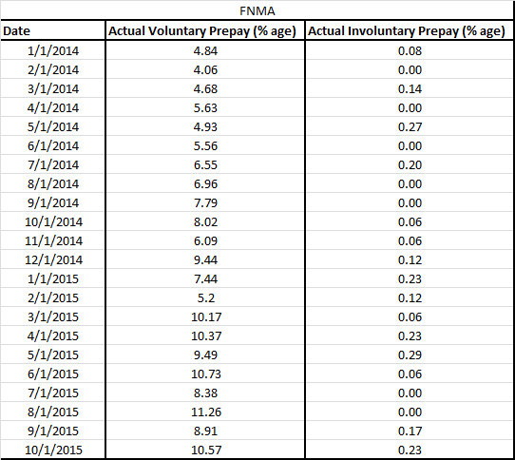

1. Model Family: MFPM v2 is implemented on the QRM platform. The INTEX cash flows and ALMIS database is used as the data source.

Background

The ALM IRR group utilizes the QRM platform for balance sheet management. The modeling of the Agency CMBS also utilizes MFPM v2 which is fully integrated into QRM. MFPM v2 is used for prepayment forecasting and the CPR vector is passed onto INTEX cash flow via QRM for cash flow modeling. To date, the Agency CMBS securities have been modeled with the QRM’s CHRM Model which is an older model that was built based on private multifamily mortgage data. The MFPM v2 model is a combination of loan and pool level model that dynamically models prepayments and addresses the need for prepayment modeling for FNMA and GNMA CMBS securities using underlying agency specific historical data.

* + MFPM v2 will be used for all regulatory stress testing exercises (e.g., CCAR, DFAST, and RRP).
  + MFPM v2 will be a part of business-as-usual monthly process that will generate risk and income projections under different interest rate scenarios. These results are reviewed by the Treasury Risk Committee, ALCO, and the Board. The Agency CMBS securities are a component of the EVE and NII forecast.

As of June 2016, the size of the Agency CMBS securities portfolio is $4.96B. The composition of the portfolio by agency is FNMA ($2.77B), GNMA ($128M) and FHLMC ($2.1B). Out of the FNMA and GNMA securities (relevant to MFPM v2 model) 61% are fixed rate loans, 31% are floating while 8% are variable hybrid loans.

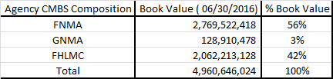

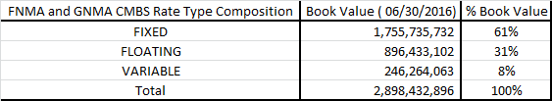

**Model Specification**

1. Methodology

**Development data**

MFPM v2 model with respect of GNMA multifamily mortgages included loans in all pools except construction pools; specifically, it included the following pool prefixes.

• LM: Project loan with delayed amortization, or with modification

• LS: Project loan without modification

• PL: Level payment FHA project loan without modification

• PN: Non-level payment FHA or rural development loan without modification

• RX: Project loan secured by lien on “mark-to-market project”

For FNMA multifamily mortgages, the model included any loans originated through FNMA’s three biggest multifamily product lines: Delegated Underwriting and Servicing (DUS), MFLEX, and Negotiated Transactions (NT). In addition to securitized mortgages, the model included some multifamily mortgages held on FNMA’s balance sheet. Further, loan-level records for all multifamily mortgages originated through FNMA’s programs were obtained from the FNMA’s website.

GNMA data sample consists of monthly panel data from January 2001 through January 2016 and FNMA data sample consists of single-observation termination records for all mortgages terminated since June 2006 or active in November 2015. Further, the monthly performance data was supplemented with additional loan-level contractual features available on GNMA’s website. Using these records, each mortgage’s history from origination to termination was reconstructed. The model’s underlying data sample for both GNMA and FNMA mortgages covers a full business cycle, including the entirety of the Great Recession. The data scrubbing chart is shown in document [1].

When fully processed, GNMA data includes 1,161,255 observations of 20,448 loans and FNMA data includes 1,578,442 observations of 28,763 loans.

Estimation

MFPM v2 is QRM’s proprietary model which estimates separate logit models for FNMA and GNMA loans. For FNMA loans, multinomial logit (MNL) model is used to describe the monthly conditional probabilities of voluntary and involuntary prepayment and depends on loan characteristics and macroeconomic variables. For GNMA loans, similar logic is used except the estimation is done via single logit model that computes probability of any type of full prepayment.

For GNMA mortgages, any payoff prior to maturity is considered full prepayment with model equation as below:

$\log\left(\frac{P_{i,t}^{p}}{1-P_{i,t}^{p}}\right)= X_{i,t}β^{p}$

Where $P_{i,t}^{p}$ is the monthly conditional probability of prepayment (equivalent to SMM) for mortgage i in month t and depends on loan characteristics and macroeconomic conditions $X_{i,t}$ with individual coefficients as $β^{p}$.

For FNMA loans, payoff of a performing loan prior to maturity is considered to be full voluntary prepayment, and payoff of a delinquent loan is considered to be involuntary prepayment. Both these events are mutually exclusive events and thus modeled using multinomial logistic regression with model equation as below:

$$\log\left(\frac{P_{i,t}^{p}}{1-P_{i,t}^{p}-P_{i,t}^{d}}\right)= X_{i,t}β^{p}$$

$$\log\left(\frac{P_{i,t}^{d}}{1-P_{i,t}^{p}-P_{i,t}^{d}}\right)= X_{i,t}β^{d}$$

Where ${ P}_{i,t}^{p}$, $P_{i,t}^{p}$ are monthly conditional probability of prepayment (equivalent to SMM) and monthly conditional probability of default (equivalent to MDR) respectively for mortgage i, in month t, and depends on loan characteristics and macroeconomic conditions $X_{i,t}$ with individual coefficients as $β^{p}$ and $β^{d}$

For details on the model equations, refer [1].

Alternative Methodologies

Alternate vendors were also explored, such as those provided by BlackRock and Moody’s. However, the model provided by those vendors does not cover Agency CMBS securities.

Assumptions

Given MFPM v2 has two underlying FNMA models (voluntary and involuntary prepay) and 1 voluntary GNMA prepay model, assumptions for each model are documented by QRM in [1]. The tables below indicate which contractual features and macroeconomic variables guide the model prepayment behavior.

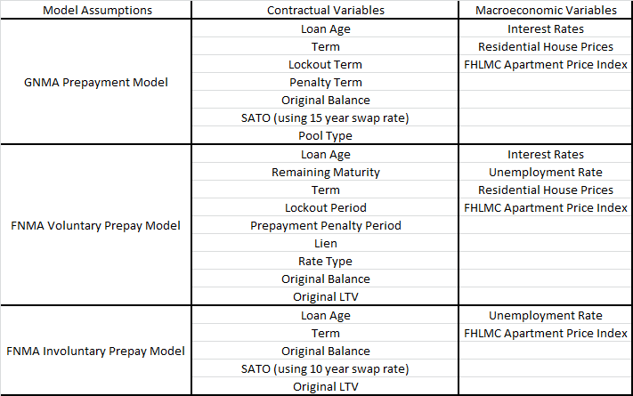

MFPM v2 utilize four macroeconomic models as input: HPI, Interest Rates, Unemployment Rate, and FHLMC Multifamily Index. For the HPI, national and local HPI forecasts are used. For the interest rates, 10y swap rate, 15y swap rate, 30 year PMMS rate, 1 year CMT rate are used. 10 year and 15 year swap rates are used to drive the refinance incentive calculations, 30 year PMMS rate is used for HPI model and 1 year CMT rate is used for unemployment rate model. QRM’s market swap rates for the 10y and 15y term points and 1 year CMT rate, 30 year PMMS rate are used in valuation and IRR’s specific forecasts except 30 year PMMS rate are used in planning scenarios. In order to support CCAR and DFAST exercise, other economic factors are also considered in the model, namely, lifetime and year-over year changes in unemployment, real GDP, commercial property prices, real personal income, and inflation, and the level of the BBB rate and the BBB spread. These variables serve as a good proxy for overall macroeconomic or credit conditions and their impact on multifamily mortgage prepayments.

**QRM’s HPI Model**

HPI index plays a crucial role in the prepayment behaviour modelling. In prepayment models, it enters into a borrower’s incentive to refinance. In home-price modelling, it enters the perception of HPI forecast. The model was built with state-level house price appreciation driven by a national factor that accounts for variation common to all states, together with regional factors that account for variation common only to subsets of states, and where national and regional factors have a simple autoregressive structure. The model also accounts for the effects of income growth and mortgage rates, and incorporating the weight associated with each state in a way that links state-level HPI to national HPI in a direct and straightforward way, while also accounting for the greater volatility of HPA in lower-population states. This version of QRM’s HPI model is interest rate path dependent. The state-level HPI is modeled by the following equation:

$${∆\log{HPI}}_{i,t}={∆\log{INC}}_{i,t}-0.096221 ∆\log{PMT(} r_{t}, 360)+γ_{i}μ_{t}+\sum_{j=1}^{J}{γ_{i,j}}μ_{j,t}+ϵ_{i,t}$$

$$\sum_{i}{ω_{i }}γ_{i}=1$$

$$\sum_{i}{ω_{i}}γ_{i,j}=0 ∀ j$$

$$γ_{i,j}=1 for some i ∈ R_{j} , ∀j$$

Where

HPIi,t is the FHFA all-transactions HPI for state i in quarter t

INCi,t  is the per-capital personal income for state I in quarter t

PMT (rt , 360) is the payment factor for a 30- year fixed mortgage with PMMS rate r in quarter t

$μ_{t}$ is the value of the national factor in quarter t

$γ_{i}$ is the coefficient of state I on the national factor

$μ_{j,t}$ is the value of regional factor j in quarter t

$γ_{i,j}$ is the coefficient of state I on regional factor j

$ϵ_{i,t}$ is the remaining contribution to HPA, specific to each state and quarter

$ω_{i}$ is the weight on state i equal to the their historical averages

$R_{j}$ comprises of the set of states defining each region

For detailed documentation on HPI model along with model equations for both state level and national level, refer to document [2].

**QRM’s Unemployment Model**

Unemployment rate is another macroeconomic variable that plays a crucial role in the prepayment behavior modelling. In prepayment models, it depicts the economic growth and higher voluntary prepay with lower unemployment rate while higher defaults leading to higher involuntary prepay with increased unemployment rate. The model is built using Box-Jenkins ARIMAX time series model relating national unemployment rate to the 1-year constant maturity Treasury (CMT) rate. IRR sources 1-year CMT rate from QRM market service download for valuation (EVE) purposes and provides our own version of rate forecast for NII planning purpose. For CCAR and DFAST, IRR will be utilizing Fed provided rates for the 1- year CMT rate and unemployment rate. Further, the unemployment rate model is interest rate path dependent (from above) and the model equation is as follows:

$$\left(∆logit U_{t}-β_{1}∆\log{r_{t}^{1yr}}- β_{2}∆\log{r_{t-1}^{1Yr}}-β_{3}∆\log{r_{t-2}^{1Yr}}\right)= \sum_{i=1}^{n}{φ_{i}}\left(∆logit U_{t-i}-β_{1}∆\log{r_{t-i-1}^{1Yr}}- β_{2}∆\log{r_{t-1}^{1Yr}}- β_{3}∆\log{r_{t-i-2}^{1Yr}}\right)+ϵ_{t}+ \sum_{j=1}^{m}{θ_{j}}ϵ_{t-j}$$

Where

Error term $ϵ_{t}$ ~ NID(0, $σ^{2}$)

Ut is the unemployment rate at time t

rt is the 1-year CMT rate at time t

$β_{1},β_{2}, β_{3}, φ_{i}, θ_{j}$ are the parameters

For detailed documentation on QRM’s unemployment rate model, refer to document [3].

**QRM’s FHLMC Apartment Price Index**

The FHLMC Apartment Price Index is an important macroeconomic variable in the logistic regression of MFPM v2 prepayment models. The model is an ARIMA time series model which uses Box-Jenkins analysis. Since the model is ARMA based, it is not interest rate path dependent. The equation for the model is as follows:

$∆\log{{API}_{t}}= \sum_{i=1}^{n}{φ_{i}}∆\log{{API}_{t-1}}+ ϵ_{t}+ \sum_{j=1}^{m}{∅_{j}}ε_{t-j}$

Where

Error term $ϵ_{t}^{2}$ ~ NID(0, $σ^{2}$)

${API}_{t}$ is FHLMC Apartment Price Index at time t

$φ_{i}, ∅_{j}$ are the parameters

For detailed documentation on QRM’s FHLMC Apartment Price Index model, refer to document [1].

1. Input Data and Data Assumptions

**Input Data**

MFPM v2 inputs include loan characteristics, interest rates, macro-economic forecasts (e.g., HPI, FHLMC Apartment Index, Unemployment Rate), and development/calibration data used by QRM for model building/calibration.

Loan contractual information is pulled into QRM from INTEX database while monthly firm specific position data is pulled from ALMIS database by a data extraction process. In the interest of model accuracy, IRR configured INTEX settings at highest resolution to ensure that collateral information passed matches with the input that MFPM v2 model takes. For INTEX resolutions, following settings were done in the QRM framework to get the highest information of data.

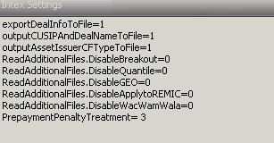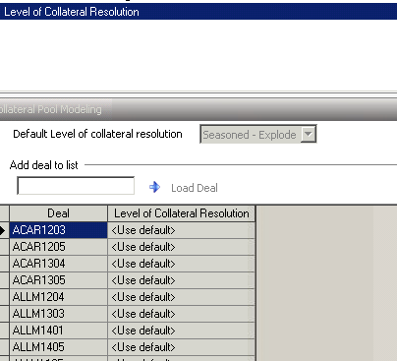

Following this, MFPM v2 model logging was turned on to capture the information model is taking for each variable and were compared with the INTEX collateral logs. After performing tests for each product type namely, FNMA and GNMA and their respective CUSIPS, IRR concluded that the data input into MFPM v2 exactly matches collateral data output. Refer attachment [4] - “Data Validation” for the data quality tests.

Interest rates in QRM’s valuation are QRM sourced and IRR-determined for planning. IRR’s interest rates use is a well-defined process that has been validated and undergoes rigorous monthly verification.

The inputs and assumptions variables used in MFPM v2 are the same for ALM-IRR production process and stress testing exercises such as CCAR. In CCAR, a custom input can be used in place of the generic QRM provided field. For example, HPI forecast for CCAR is a custom input and not the HPI model forecast provided by QRM.

1. Calculations

Since the behavioral output of MFPM v2 is CPR, it is necessary to understand how QRM reports these numbers. CPR vectors in QRM are pool-level numbers, further given no default model in MFPM v2 the CPR reported is total prepayment inclusive of involuntary prepayment in case of FNMA mortgages.

**Testing the Model**

1. Analysis of the Model

Assumption Validity

QRM performed extensive validation of the model and monitors its performance regularly. The following documents are relevant to validation: [1], [5] and [6].

QRM provides an online module for MFPM v2 model performance, where the user can fixate on various vintages and product type to test the performance of the model.

QRM Implementation

MFPM v2 was implemented by setting up a behavioral model link in QRM. Through the model link, we set up the data inputs for the model (see below for a screenshot of the QRM interface). As mentioned in the input data section, we were able to reconcile the source data with the data passed into MFPM v2 using the model logging file. For further details about QRM implementation, please see [1].

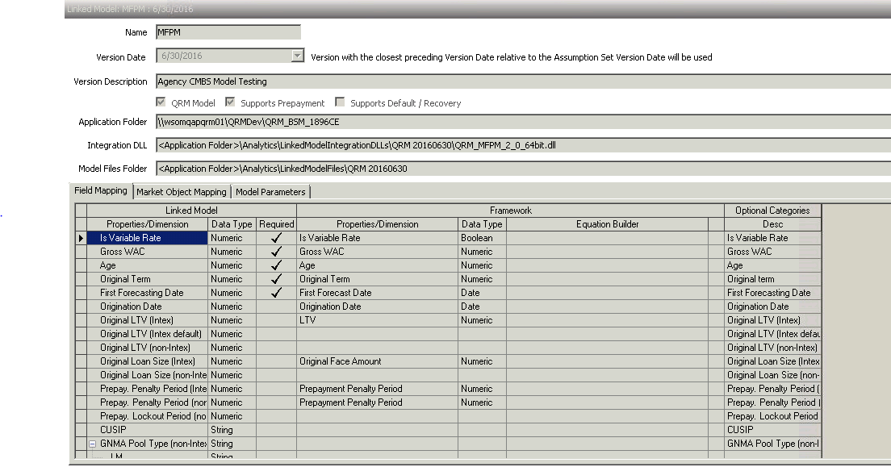

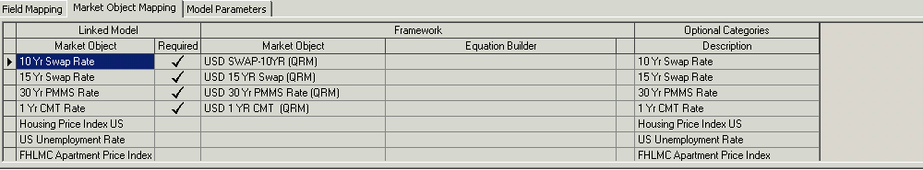

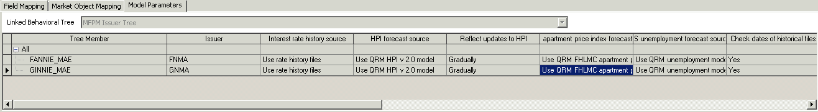

The default issuer has been set at FNMA if we don’t use the “MFPM Issuer Tree” methodology. IRR implemented, the issuer tree to ensure that the deals are correctly mapped product wise and will give us the flexibility to shock voluntary, involuntary prepayments on product level.

Back-testing and Tuning

ALM-IRR views back-testing and tuning of prepayment models as parts of the same process. That is, a model’s performance is assessed by performing historical back-testing on the behavioral outputs (e.g., CPR) and if a particular tuning group is out of acceptable range of accuracy, it is then tuned. Back-testing is performed monthly and tuning is performed, at least, on a quarterly frequency.

Our back-testing/tuning groups are defined based on the MFPM v2 tuning product groups determined by QRM. We initially set up our grouping to exactly match with the QRM grouping aka FNMA and GNMA. Based on the law of large numbers, sample size needs to be big enough to show a stable read of historical CPR/CDR metrics. However, the firm only holds a very small portion of these securities and these securities have long prepayment penalty lockouts. Further, ALMIS database did not have amortization type, and amortization years to be able to manually calculate the scheduled principal for these securities. The underlying methodology was to back out the calculated scheduled principal from the change in face amount of these securities month over month to be able to calculate unscheduled principal which drives the prepayment. Given the limitation from our database, IRR ran realized interest rate scenario in QRM to get the unscheduled principal for these securities while using ALMIS database to get the change in face amount month over month. The reason for running in QRM was INTEX is able to provide the necessary fields for QRM to calculate scheduled principal and so by using realized rates; we could get realized unscheduled principal. Furthermore, given IRR does not have INTEX application individual license, we had to use QRM to interact with INTEX. IRR performed such calculation for 3 historical months, but given the small sample size of our securities, the prepayment tuning was deemed unacceptable. We also extended our 3 month tuning practice to 6 months but even after that the tuning vectors were not reliable. Also, such tuning was on total prepayment and not split between involuntary and voluntary prepayment for FNMA. QRM behavioral modeling team confirmed to use the tuning vector on voluntary alone, given involuntary is a very small portion of total prepay and has been historically very sporadic. As the tuning performed by IRR was not reliable, we turned back to vintage performance tuning, and individual model performance and found that model was a perfect fit with no tuning necessary. IRR also utilized vintage performance of the model, since firm securities were majorly after 2012 originations. For details on the IRR backtest and tuning, refer document [7]. For QRM backtest and tuning, refer document [8] and for vintage specific performance, refer document [5]. IRR is working with QRM to be able to load firm specific deals to QRM’s model monitoring platform to be able to perform tuning; however given model is perfect fit, it was deemed acceptable to not perform tuning. Below shows the final results of IRR performed tuning trial exercise.

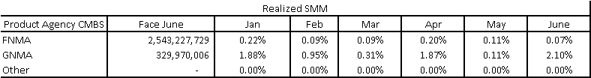

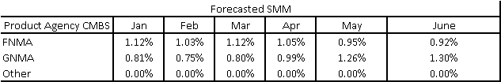

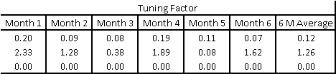

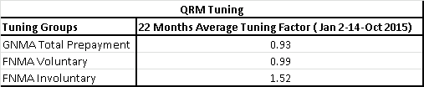

The steps followed in reaching above tuning factors included calculating historical SMM and using MFPM v2 for projected SMM for each tuning group for a period of 6 months (Jan 2016- June 2016). A ratio is calculated by comparing actual SMM with projected SMM to quantify the amount of tunings needed. The following formulas show the mathematical form of these ratios. If for a particular group, this ratio is outside of the range between 0.8 and 1.2, it implies that MFPM v2 forecast is too far away from the actual prepayments and a tuning adjustment is needed. As can be seen, the tuning factors calculated were in conflict with model tunings that were performed by QRM’s behavioral modeling team on the universe of these securities. Also, since the FNMA involuntary prepay was very sporadic, standard errors were high leading to tuning factor of 1.50 being statistically indifferent from 1 and thus no tuning required on this class as well. The following formulas show the mathematical form of these tuning ratios:

$$Tuning Ratio=\frac{\sum_{i=1}^{6}{\frac{{SMM}_{i, realized}}{{SMM}_{i, forecast}}}}{6}$$

Realized SMM Calculation

We calculated historical CPR and SMM based on changes in balance (face amount) and scheduled principal. The following formulas reflect how we calculated SMM and CPR:

$$SMM=max( {UPB}_{1}-P^{s}-{UPB}_{2},0)$$

$$CPR=1-{\left(1-SMM\right)}^{12}$$

$$where the scheduled principal, P^{s}=total monthly payment-gross interest;$$

$${UPB}_{i} stands for unpaid balance for month i$$

**Benchmarking**

IRR tried to use BlackRock and Moody’s to benchmark MFPM v2 model, however both vendors currently don’t have the model that supports Agency CMBS securities. IRR plans to utilize the models once the vendors release it in near future.

Model fidelity (stability and behavior)

As described earlier, QRM pulls loan data for MFPM v2 from INTEX and starting monthly position data from ALMIS. Other necessary inputs are gathered by QRM from their historical/forecasting file (provided monthly). IRR controls the level of interest rates for NII runs based on our forecast.

**Sensitivity to Interest Rate**

IRR conducted the tests to quantify the sensitivity of MFPM v2 CPR forecast to the shocks in the interest rates, refer document [9].

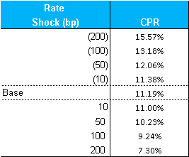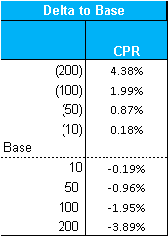

CPR decreases while interest rates increase and vice versa. The changes in CPR for down rate scenarios are larger than those for up rate scenarios. This is intuitive since CPR is floored at the turnover speed, and matched with the marginal plots built during model building and can be seen in QRM model document [1].

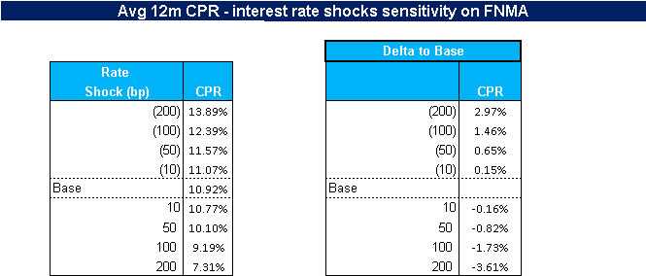

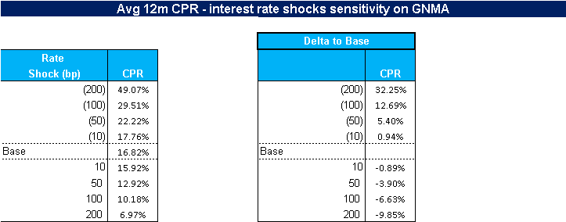

**Sensitivity to HPI**

Testing is also performed to show CPR sensitivities to HPI shocks, refer document [9]. The HPI is a one path obtained based on the implied forward base scenario created by IRR and followed by shocks on that HPI rates.

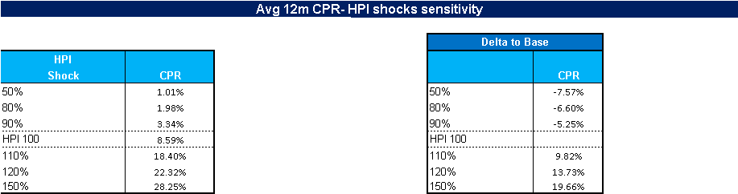

When HPI decreases, CPR decreases however the lowest limit of CPR is 0. When HPI increases, CPR increases and borrowers have higher incentive to prepay than the cost of penalty of prepaying, giving an increased prepayment behavior with jumps in HPI. IRR further extended the sensitivity to product specific FNMA and GNMA and the results were aligned with the QRM model document marginal plots.

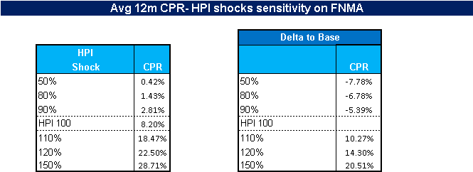

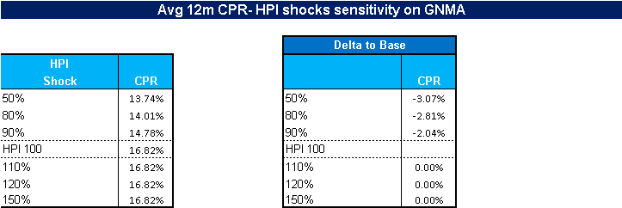

**Sensitivity to Unemployment Rates**

Testing was performed to show CPR sensitivities to Unemployment rate shocks, refer document [9]. The unemployment rate is a one path obtained based on the implied forward base scenario created by IRR and followed by shocks on that unemployment rates.

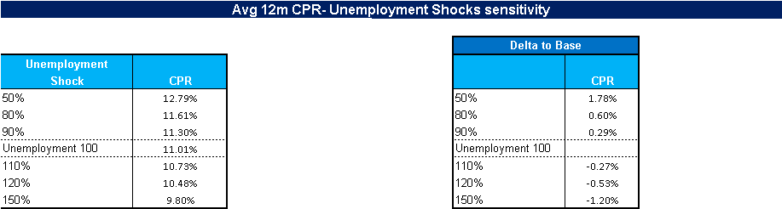

When unemployment rate increases, CPR decreases although offset by the increase in defaults leading to higher involuntary prepay. When unemployment decreases, CPR increases. Similar to HPI shocks, the tests were broken down to product level as below. Further, given GNMA prepayment model is not based on unemployment rate as one of the macro variables, there was no sensitivity as expected. FNMA results matched with QRM model document marginal plots created during model building.

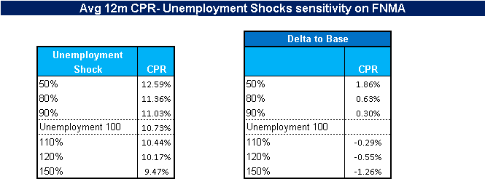

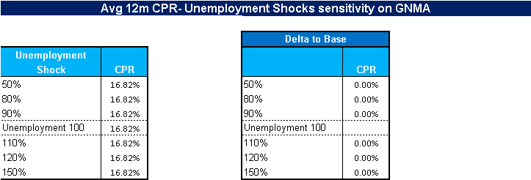

**Sensitivity to FHLMC Apartment Index**

Testing was performed to show CPR sensitivities to FHLMC Apartment Index shocks, refer document [9]. The FHLMC Apartment Index is a one path obtained based on the implied forward base scenario created by IRR and followed by shocks on that index.

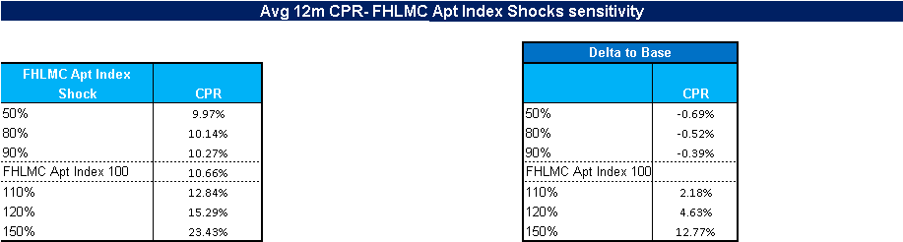

Increase in FHLMC Apartment Index creates more financing opportunities with better terms aka similar behavior with CPR as HPI; however with decrease in the index CPR tends to show less sensitivity with the index unlike HPI. The tests were broken down at product level and the behavior confirmed with the marginal plots of model building using FHLMC Apartment Index on Page 26 of attached document [1].

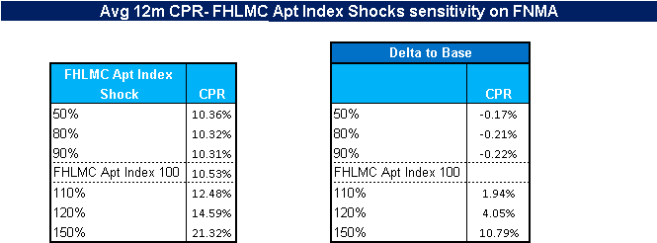

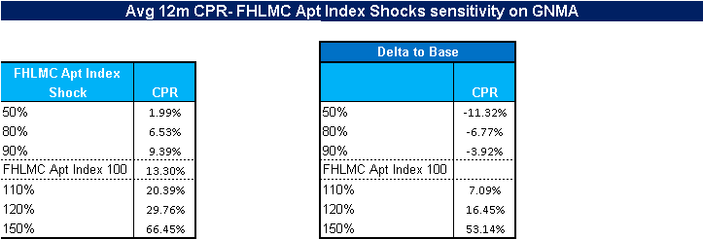

**Market Value Sensitivity**

Sensitivity testing is performed with respect to shifts in CPR, refer document [9].

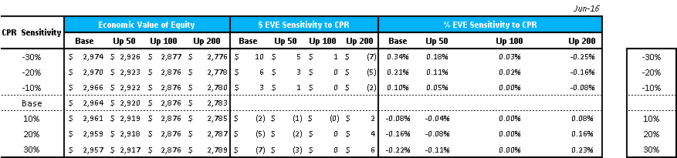

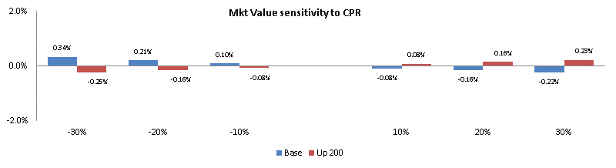

Higher CPR affects the market value by pulling it to the face amount (par). When CPR increases and everything else holds, rather than getting the expected value (market value), the investor will get cash prepayments (equals to the face amount) from borrowers. For the base, up 50 and up 100 interest rate scenario, since Agency CMBS securities are valued above par. However, in up 200 interest rate scenario, the market value of these securities drops below par. For this reason, while CPR increases, the market value also increases as the securities will pull towards par. Further, the tests were performed by individually shocking voluntary prepayment for GNMA while keeping involuntary and GNMA prepayment at base level. These tests were then extended to individual involuntary shocking of FNMA and GNMA prepayment shocking respectively. Results aligned with the marginal plots developed during model building and can be seen in the QRM model document [1]. Also, given involuntary prepayment of FNMA is a very small portion of total prepayment, the impact was minimal as expected. However, given technical difficulty in shocking, Base level voluntary and involuntary shocks represent sensitivity of Economic Value (zero-volatility and thus no MTM spread but prepayment included), while parallel shocks represent Market Value sensitivity. Currently QRM does not report Economic Value for shocks, and thus the limitation. The total CPR shocks are although representing Market Value sensitivity for both Base and Market Value.

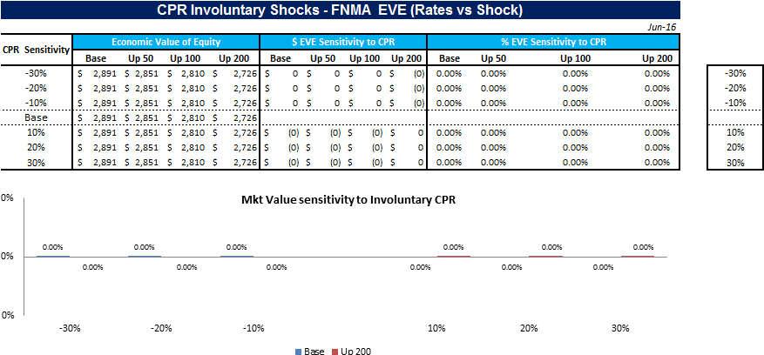

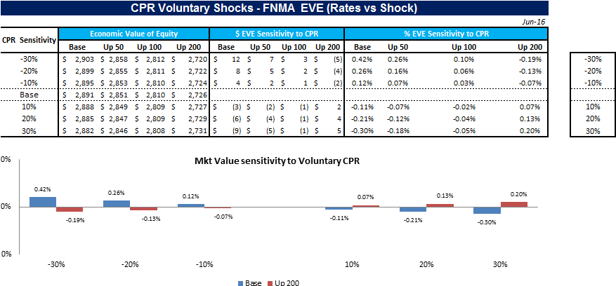

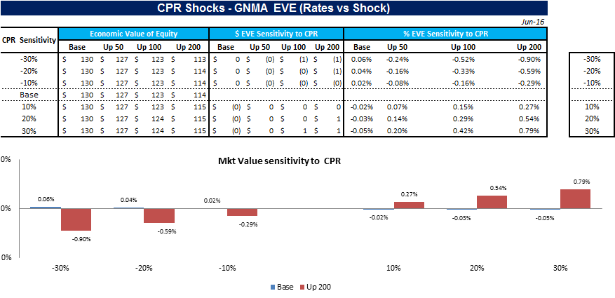

**NII Sensitivity**

NII sensitivity testing is performed with respect to shifts in CPR using run-off Agency CMBS portfolio with no reinvestments, refer document [9].

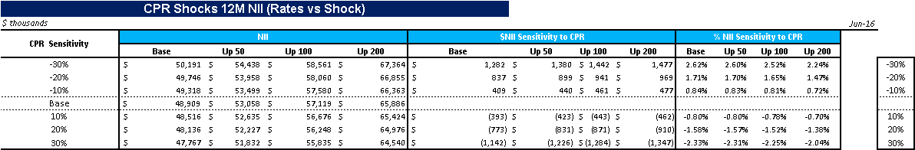

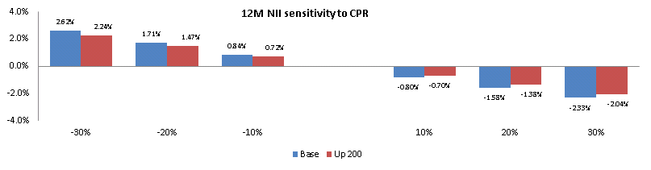

As expected, with decrease in CPR under all interest rate scenarios shown above, NII increases. Primarily as the securities will last longer due to slower prepay and the amortization on the premium for these securities will slow down. A breakdown of NII into coupon income and change in accrued interest along with amortization is shown below.

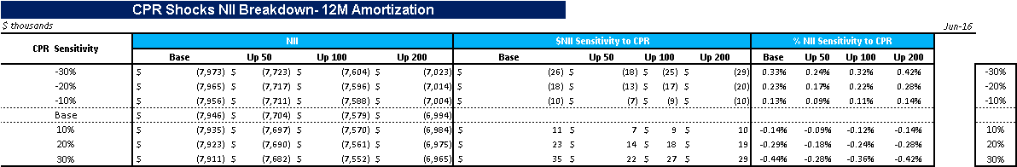

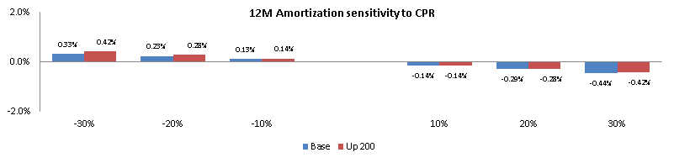

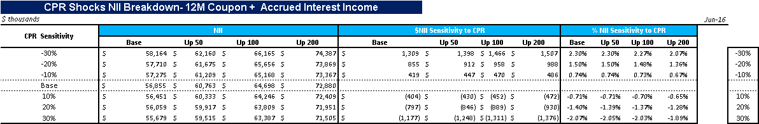

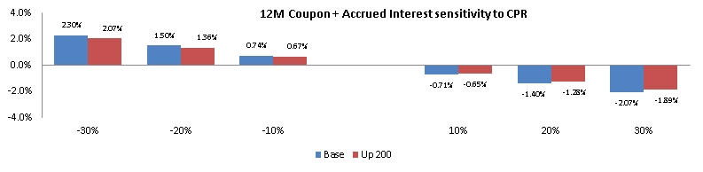

Further, the tests were performed at product and voluntary and involuntary level as below. Stability and behavior of CPR shocks will be reviewed on an on-going basis. Model validation performs annual model reviews, during which IRR can review/test modeling concerns in tandem.

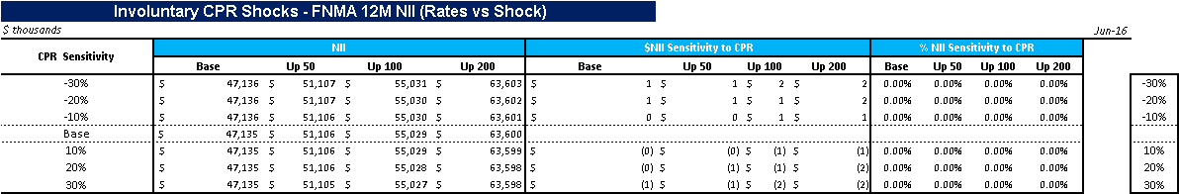

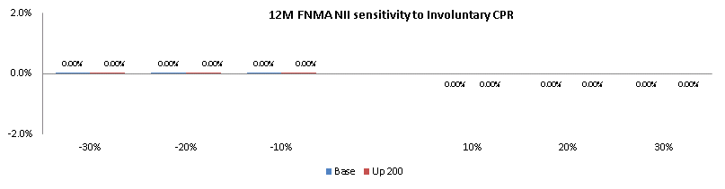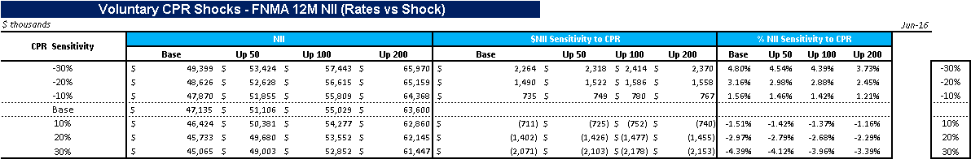

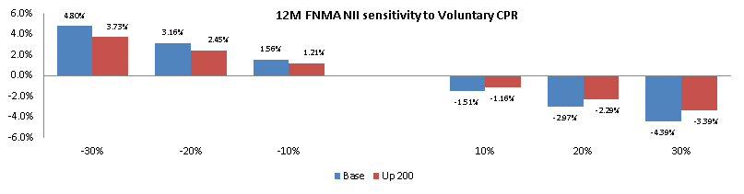

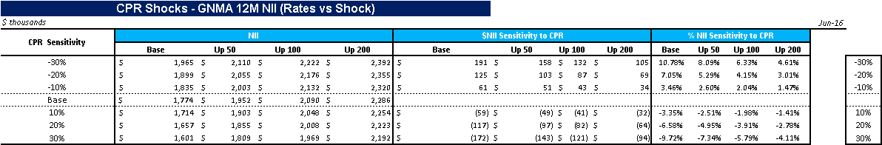

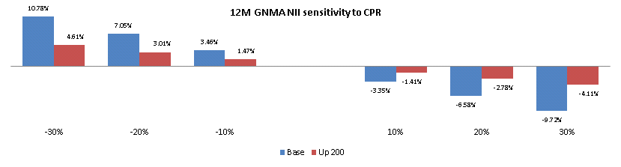

1. Analysis of Implementation

Implementation test was performed for FNMA and GNMA Agency CMBS securities to attribute the differences that will come by bringing the MFPM v2 to production. The tests were performed to attribute the differences individually for EVE and NII.

**MFPM v2 EVE VS CHRM old Model EVE**

Understanding the differences in valuation for the currently used QRM CHRM prepayment model and MFPM v2 prepayment model, we commenced implementation test, refer document [10].



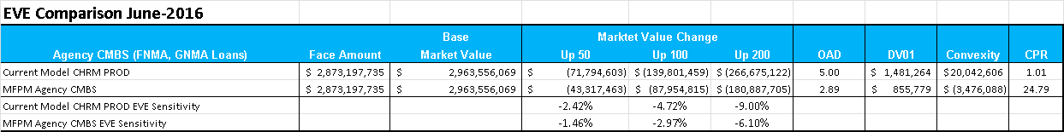

The difference in EVE results are mostly due to the change in prepayment forecast. The current model of CPR forecasting understates the actual prepayment with a heavy margin. After running the analysis with the MFPM v2 upgrade, the OAD measure is ~1.91Yr lower driven by the higher projected CPR’s. Further, in the interest of using the model for CCAR and DFAST stress testing, IRR ran the similar analysis by allowing USD LIBOR/SWAP and USD Treasury rate (which impact these models) to -500 bps during which the OAD measure is ~ 2.11 Yr lower than the older model. When rates are allowed to go negative, there are two competing forces that impact the prepayment option value:

* Allowing negative rates should generally lead to an increase in prepayment speed and thus should increase the value of the prepayment option (and a decrease in duration)
* Increase in the non- floored values of all Monte-Carlo rate paths should generally result in a decrease in prepayment option value (and an increase in duration).

The latter statement is true due to the following reason: When a non-zero servicing fee is used to allow for negative rates, the positive parts and maximum values of short rate paths generated by MC method would move up, compared with the zero servicing fee case. This effect is due to the no-arbitrage property of the short rate paths, which guarantees that the average discount factors along MC paths are always equal to those over static (implied forward) curve. In other words, zero coupon bond prices over MC paths are always the same as the off-curve (static) prices. Increasing servicing fee means that short rate paths are floored at a more negative level and, as a result, the average of path discount factors goes up.  To enforce the no-arbitrage condition we need to bring the average of path discount factors down by adjusting the no-arbitrage drift upward resulting in an increase in the positive parts and maximum values of short rate paths.

IRR concluded the analysis by analyzing the impact of negative rates alone on the new model’s OAD and Convexity measures and found the which duration remained relatively stable on the new model with and without negative rate allowed, convexity decreased with negative rates by 3M in comparison to the model ran with no negative rates. This phenomenon can be attributed to the above explanation of impact of negative rates and for the analysis on specific CUSIPS, refer to document [11].

**MFPM v2 NII VS CHRM old Model NII**

Similarly, IRR performed the analysis on business as usual Agency CMBS Strategy of reinvestment and by allowing -500 bps negative rates. Prepay forecast is also lower for the interest income projection along with slower amortization in the older model. With the new model, CPR’s projection is higher leading to reduced income in the base interest rate scenario as they are 100% reinvested at a coupon which is lower than the rate these positions were earning without prepay along with higher amortization pulling to par. However, when rates go up, in the new model these positions stick out longer and earn a higher income. While the same phenomenon is true in the old model too, but since the CPR in older model was too low (0.39% 12M CPR), the impact of increased interest rates on the CPR would yield a lower upside potential of income sensitivity with rates being higher. The charts of the results are shown below, refer document [9] for the complete analysis.

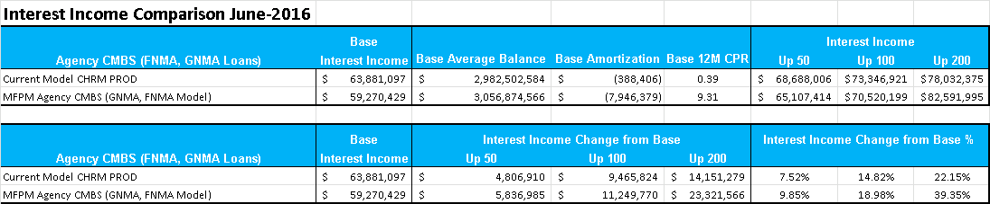

1. Ongoing Performance Monitoring Plan

IRR is working with QRM to be able to load their deals onto the online module for back testing and tuning. Further, IRR will also venture to see if the back testing can be performed by getting license for INTEX application. That being said, in the meantime IRR will be utilizing QRM’s back testing both product level and vintage level on a quarterly basis for model performance. The results will be reported to the head of IRR, Treasury Market Risk, and ALCO.

IRR plans to investigate the feasibility to perform its own version of HPI back testing to monitor the performance of QRM’s HPI model to ensure the vendor’s sound modeling of macroeconomic variables. However, since the MFPM v2 uses HPI as a stand-alone macro variable, IRR has utilized QRM’s back testing of HPI, FHLMC Apartment Index and Unemployment rate for this model. Further, IRR plans to complement the shocking of CPR’s for EVE and NII analysis into voluntary and involuntary for FNMA Agency CMBS securities. Given involuntary was a very small portion of prepay and quite sporadic historically, it was deemed acceptable to shock overall CPR for the model testing.

**References for Model Documentation:**

[1] “MFPM v2 Model Document”, QRM (PDF document)



[2] “HPI Model”, QRM (PDF document)



[3] “Unemployment Model”, QRM (PDF document)



[4] “Data Validation”, IRR (Excel Spreadsheet)



[5] “MFPM v2 backtest by vintages and macroeconomic variable backtest”, QRM (PDF document)



[6] “MFPM v2 Online Model Monitoring Module”, [https://clients.qrm.com/](https://www.ad-co.com/otr_model_demos_ldm20), QRM

[7] “IRR Backtesting MFPM v2”, IRR (Excel Spreadsheet)



[8] “QRM Backtest by Product”, QRM, (Excel Spreadsheet)



[9] “Sensitivity Tests”, IRR (Excel spreadsheet)



[10] “Valuation Impact Old vs New Model”, IRR (Excel Spreadsheet)



[11] “Negative Rate Servicing Fees Impact” (Excel spreadsheet)



**Change Log**

**Revision History of Model**

|  |  |  |  |  |
| --- | --- | --- | --- | --- |
| **Date** | **Section** | **Description of Change** | **Validation of Change** | **Validation Date** |
| 10/12/16 | All | Document being created (Harmandeep Saini) |  |  |
|  |  |  |  |  |
|  |  |  |  |  |
|  |  |  |  |  |
|  |  |  |  |  |